HEALTH ANALYTICS INGESTION PIPELINE
A Serverless ETL Pipeline using Amazon S3, AWS Lambda, and Amazon DynamoDB

1. Project Overview

1.1 Business Scenario
A healthcare analytics team receives COVID-19 data in CSV format from public health sources. The raw dataset is stored in Amazon S3, where AWS Lambda validates and transforms the records. The cleaned data is then loaded into Amazon DynamoDB for analytics and reporting.

1.2 Dataset & Source
Attribute | Detail
Dataset | country_wise_latest.csv
Source | Kaggle – Corona Virus Report (imdevskp)
https://www.kaggle.com/datasets/imdevskp/corona-virus-report?select=country_wise_latest.csv

2. AWS Architecture Design
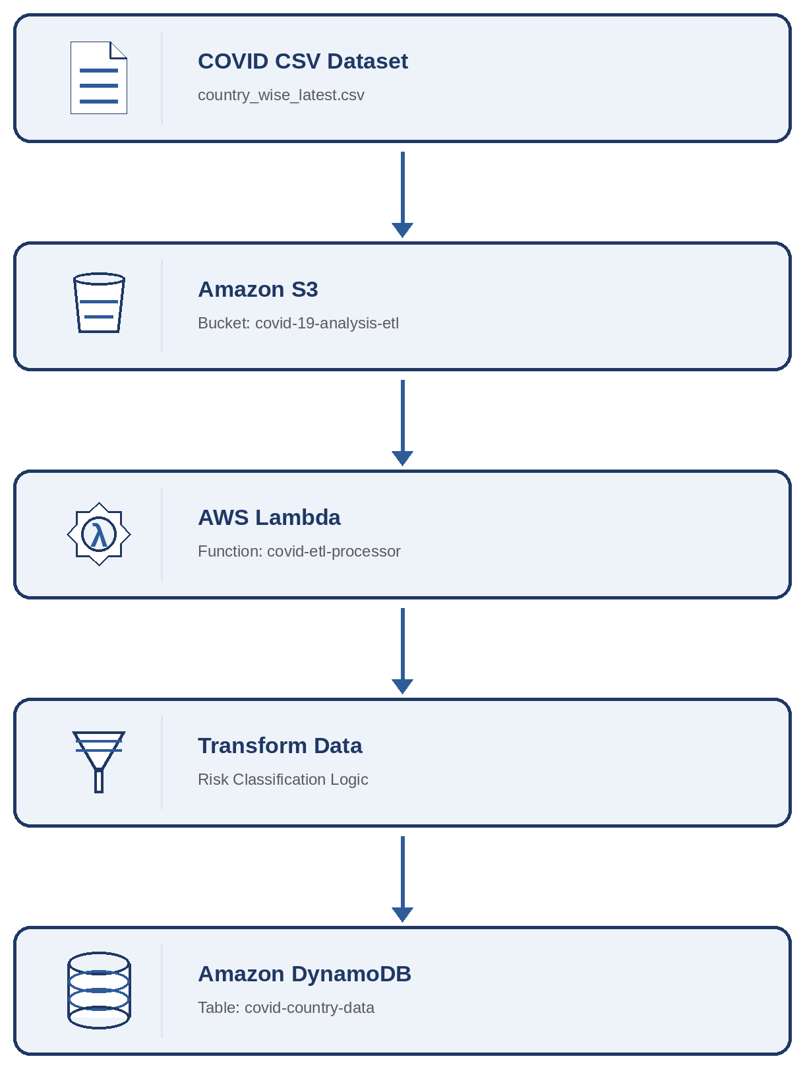

2.1 Architecture Layers
Layer | AWS Service
Source | country_wise_latest.csv
Storage Layer | Amazon S3
Processing Layer | AWS Lambda
Database Layer | Amazon DynamoDB

3. ETL Flow

3.1 Extract
- Read CSV from S3

3.2 Transform
- Rename Country/Region → country
- Rename WHO Region → who_region
- Create risk_status column
- Handle missing values

3.3 Load
- Store transformed records into DynamoDB

4. Implementation Details

4.1 Amazon DynamoDB Table Creation
Amazon DynamoDB was used as the target NoSQL database for storing transformed COVID-19 records. A table named covid-country-data was created with country as the partition key. The table stores country-wise COVID statistics after data validation and transformation.
Table Detail | Value
Table Name | covid-country-data
Partition Key | country (String)
Database Type | NoSQL (Amazon DynamoDB)
The DynamoDB table acts as the final storage layer in the ETL pipeline, where cleaned and transformed records are loaded for analytics and reporting.

4.2 AWS Lambda Function Creation
AWS Lambda was used as the processing layer of the ETL pipeline. A serverless function named covid-etl-processor was created using the Python 3.12 runtime. The Lambda function is responsible for:
- Reading the COVID-19 CSV dataset from Amazon S3
- Performing data validation and transformation
- Generating a risk classification for each country
- Loading transformed records into Amazon DynamoDB
Using AWS Lambda eliminates the need to manage servers and enables automatic execution of ETL workloads.

4.3 Lambda Environment Configuration
Environment variables were configured in the AWS Lambda function to make the ETL pipeline reusable and configurable.
Variable | Value
S3_BUCKET | covid-19-analysis-etl
S3_KEY | covid-data/country_wise_latest.csv
DYNAMODB_TABLE | covid-country-data
Using environment variables avoids hardcoding resource names inside the source code and improves maintainability.

4.4 ETL Transformations Implemented
The Lambda function performs the following transformations:
- Renamed source columns into business-friendly attributes
- Converted numeric values into integer format
- Generated a derived field called risk_status
- Classified countries into High Risk, Medium Risk, and Low Risk categories based on confirmed cases

Transformation Logic
Condition | Risk Status
Confirmed Cases > 100,000 | High Risk
Confirmed Cases > 10,000 | Medium Risk
Otherwise | Low Risk
These transformations improve data quality and make the dataset more suitable for analytics.

4.5 Lambda Function Code
import csv
import io
import json
import os
from decimal import Decimal
import boto3

S3_BUCKET = os.environ["S3_BUCKET"]
S3_KEY = os.environ["S3_KEY"]
DYNAMODB_TABLE = os.environ["DYNAMODB_TABLE"]

def lambda_handler(event, context):
s3 = boto3.client("s3")
dynamodb = boto3.resource("dynamodb")
table = dynamodb.Table(DYNAMODB_TABLE)

response = s3.get_object(
Bucket=S3_BUCKET,
Key=S3_KEY
)
csv_content = response["Body"].read().decode("utf-8")
reader = csv.DictReader(io.StringIO(csv_content))
records_written = 0

with table.batch_writer() as batch:
for row in reader:
country = row["Country/Region"]
confirmed = int(float(row["Confirmed"]))
deaths = int(float(row["Deaths"]))
recovered = int(float(row["Recovered"]))
active = int(float(row["Active"]))
who_region = row["WHO Region"]

# Transformation
if confirmed > 100000:
risk_status = "High Risk"
elif confirmed > 10000:
risk_status = "Medium Risk"
else:
risk_status = "Low Risk"

item = {
"country": country,
"confirmed": confirmed,
"deaths": deaths,
"recovered": recovered,
"active": active,
"who_region": who_region,
"risk_status": risk_status
}

batch.put_item(Item=item)
records_written += 1

return {
"statusCode": 200,
"body": json.dumps({
"message": "COVID ETL completed successfully",
"records_written": records_written
})
}

5. IAM Permissions Configuration
AWS Identity and Access Management (IAM) policies were configured to provide secure access to AWS resources. The Lambda execution role was granted the following permissions:
Service | Permission | Purpose
Amazon S3 | s3:GetObject | Allows Lambda to read the COVID-19 CSV dataset stored in the S3 bucket
Amazon DynamoDB | dynamodb:PutItem | Allows Lambda to insert transformed records into the DynamoDB table
Amazon DynamoDB | dynamodb:BatchWriteItem | Allows Lambda to insert transformed records into the DynamoDB table
The principle of least privilege was followed by granting only the permissions required for ETL processing.
Troubleshooting Note
During testing, the Lambda function initially failed due to the default execution timeout of 3 seconds. The timeout was increased to 30 seconds and memory allocation was increased to 256 MB to support processing of larger CSV datasets. After the configuration update, the ETL pipeline executed successfully.

6. ETL Execution Results
The ETL pipeline executed successfully using AWS Lambda. The COVID-19 dataset stored in Amazon S3 was processed and loaded into Amazon DynamoDB.
Metric | Value
Source Dataset | country_wise_latest.csv
Storage Layer | Amazon S3
Processing Layer | AWS Lambda
Target Database | Amazon DynamoDB
Records Processed | 187
Records Loaded | 187
The Lambda function successfully validated, transformed, and inserted all records into the DynamoDB table. The transformed dataset included a derived attribute called risk_status, which classified countries based on confirmed COVID-19 cases. The successful execution demonstrated the implementation of a serverless ETL pipeline using AWS services.

7. Conclusion
A serverless ETL pipeline was successfully developed using AWS services. The COVID-19 dataset was stored in Amazon S3, processed using AWS Lambda, transformed according to business rules, and loaded into Amazon DynamoDB.
The solution demonstrated the practical implementation of Extract, Transform, and Load (ETL) concepts using cloud-native services. A total of 187 records were processed and inserted into DynamoDB. Additional business logic was implemented by classifying countries into risk categories based on confirmed COVID-19 cases.
This project highlighted the advantages of serverless architectures, including scalability, reduced operational overhead, and cost efficiency.

7. Screenshots

7.1 S3 Bucket with CSV file

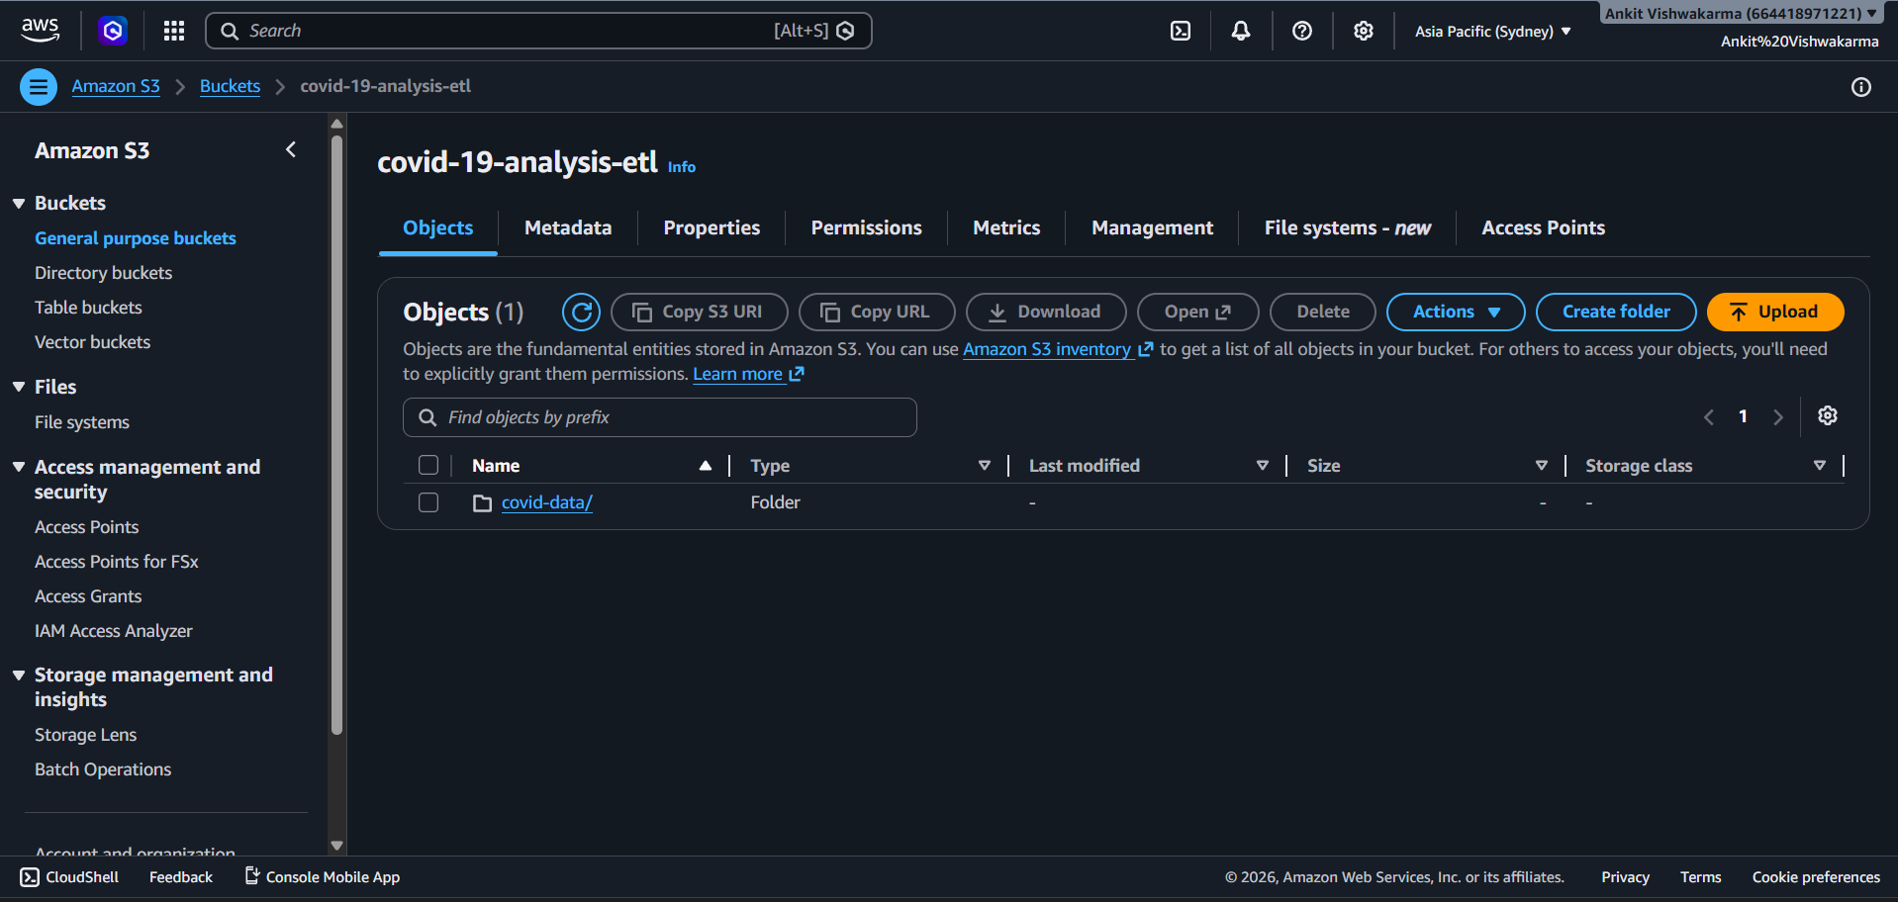

7.2 DynamoDB Table Creation

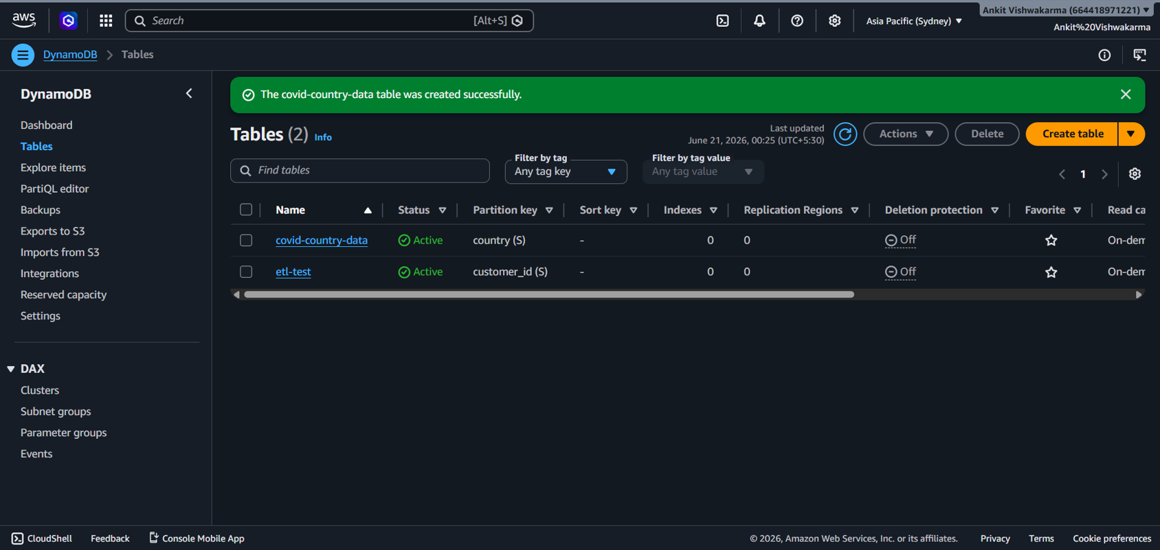

7.3 Lambda Function

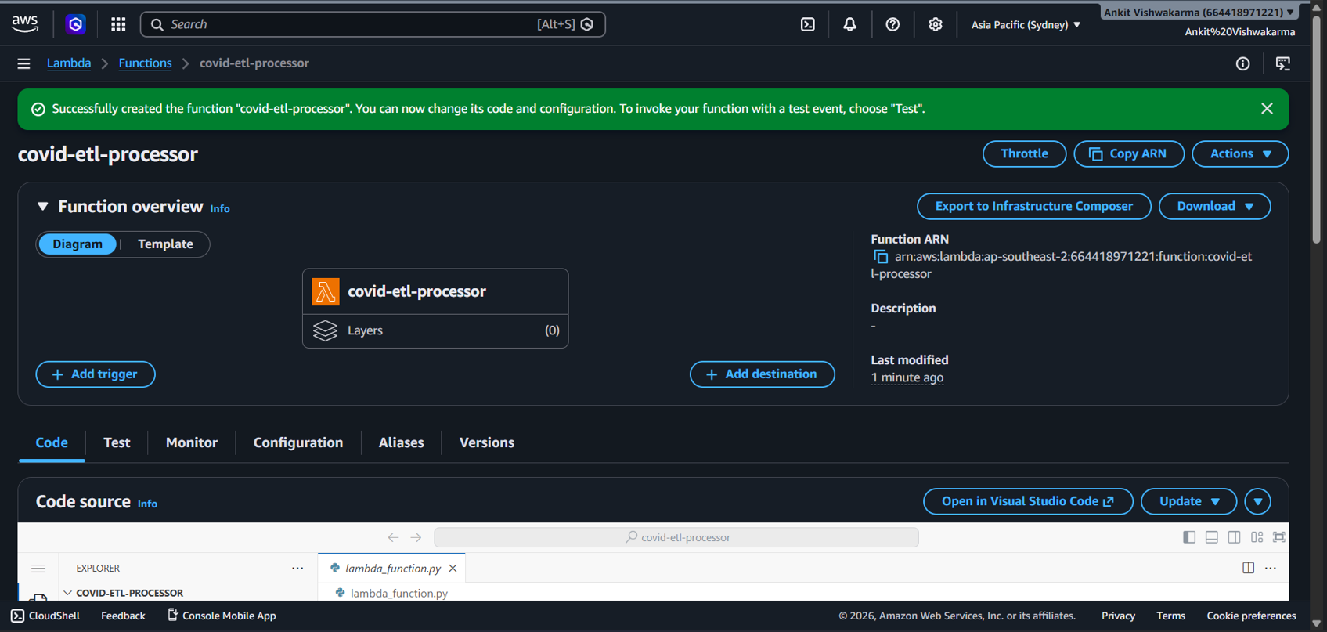

7.4 Lambda Function Code

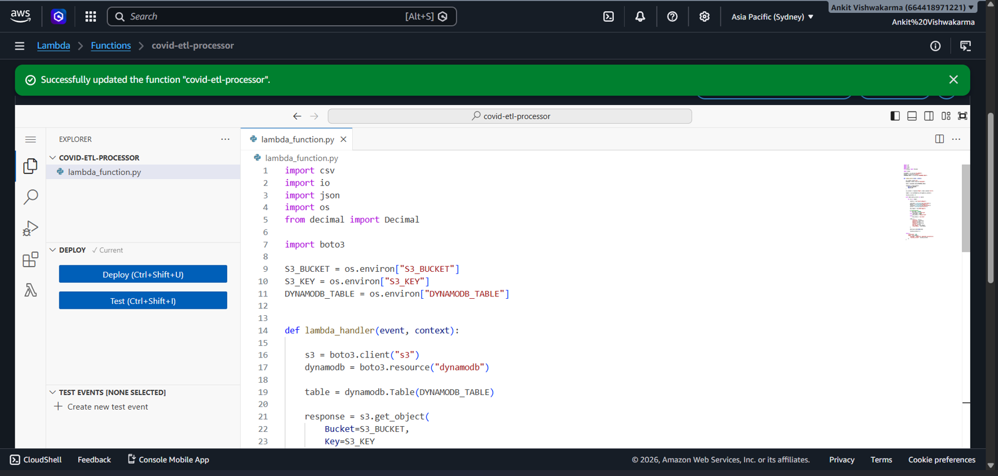

7.5 Lambda Function Environment Variables

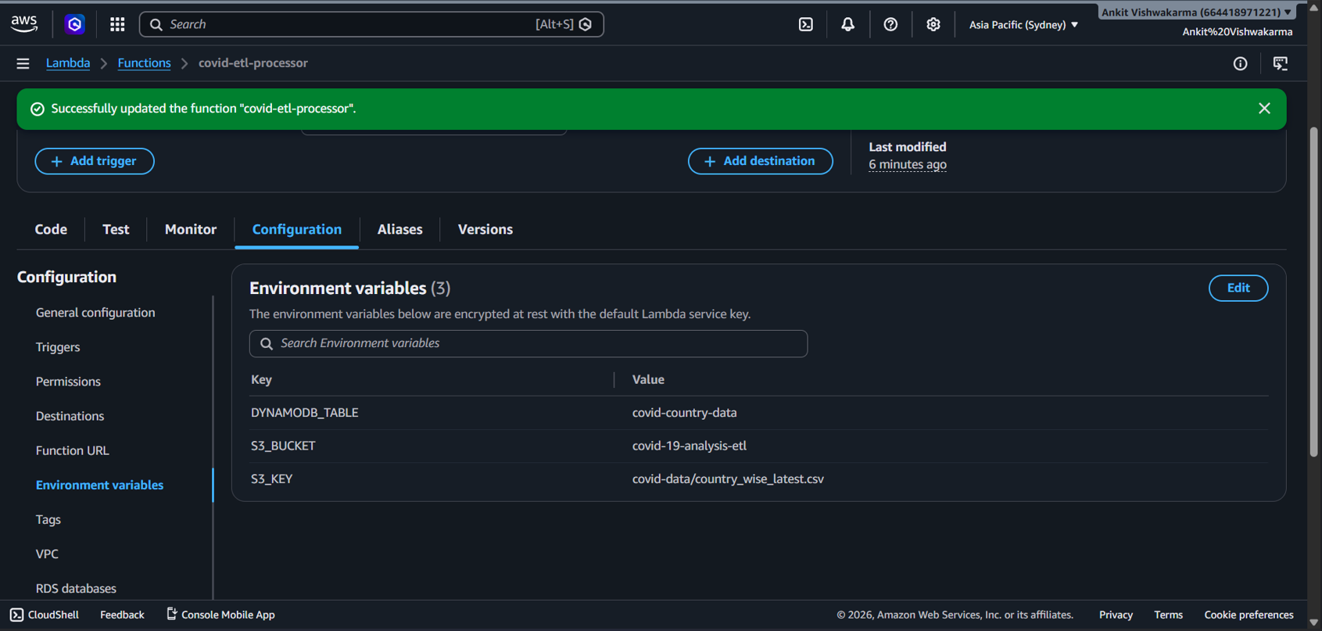

7.6.1 IAM Policies (S3 Policy)

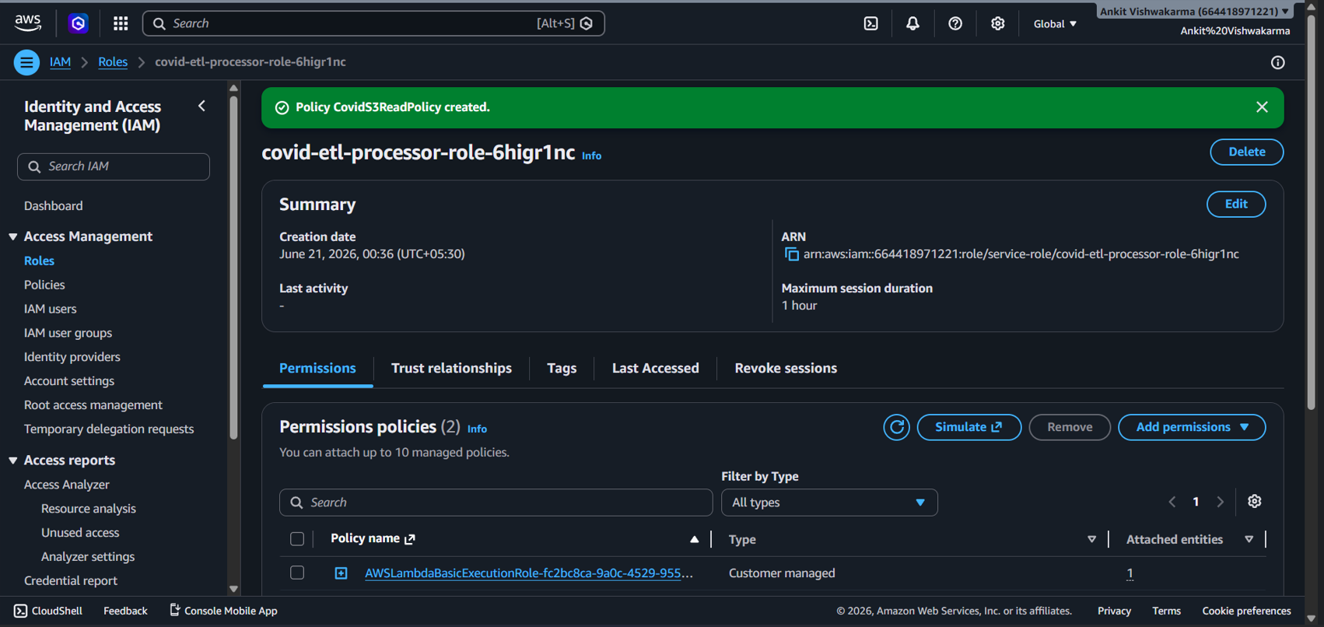

7.6.2 IAM Policies (DynamoDB Policy)

7.7 DynamoDB Records

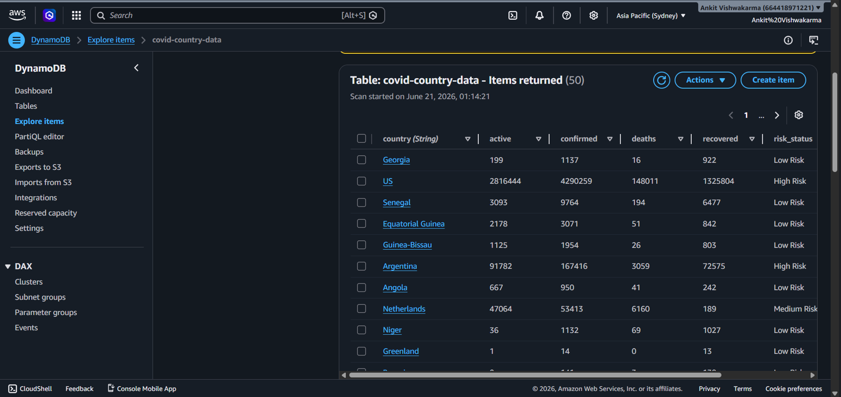

8. Reflection Questions

1. Why is S3 a good landing zone for raw files?
Amazon S3 is highly scalable, durable, and cost-effective. It is ideal for storing raw data before processing.

2. Why is Lambda suitable for this small ETL workload?
AWS Lambda is serverless, automatically scales, and charges only for execution time, making it cost-efficient for small ETL jobs.

3. Why did you choose your DynamoDB partition key?
I chose country as the partition key because it uniquely identifies each record and enables fast lookups.

4. What is the difference between storing this data in DynamoDB vs RDS?
- DynamoDB: NoSQL, schema-flexible, highly scalable, low-latency access.
- RDS: Relational database, supports SQL, fixed schema, better for complex joins and transactions.

5. Why should we avoid scanning large DynamoDB tables in production?
Scanning reads every item in the table, which increases latency, consumes more read capacity, and raises costs.

6. What IAM permissions did your Lambda function need?
- S3: s3:GetObject (to read the CSV file)
- DynamoDB: dynamodb:PutItem, dynamodb:BatchWriteItem (to insert records)
- CloudWatch Logs: Basic Lambda execution permissions for logging.

